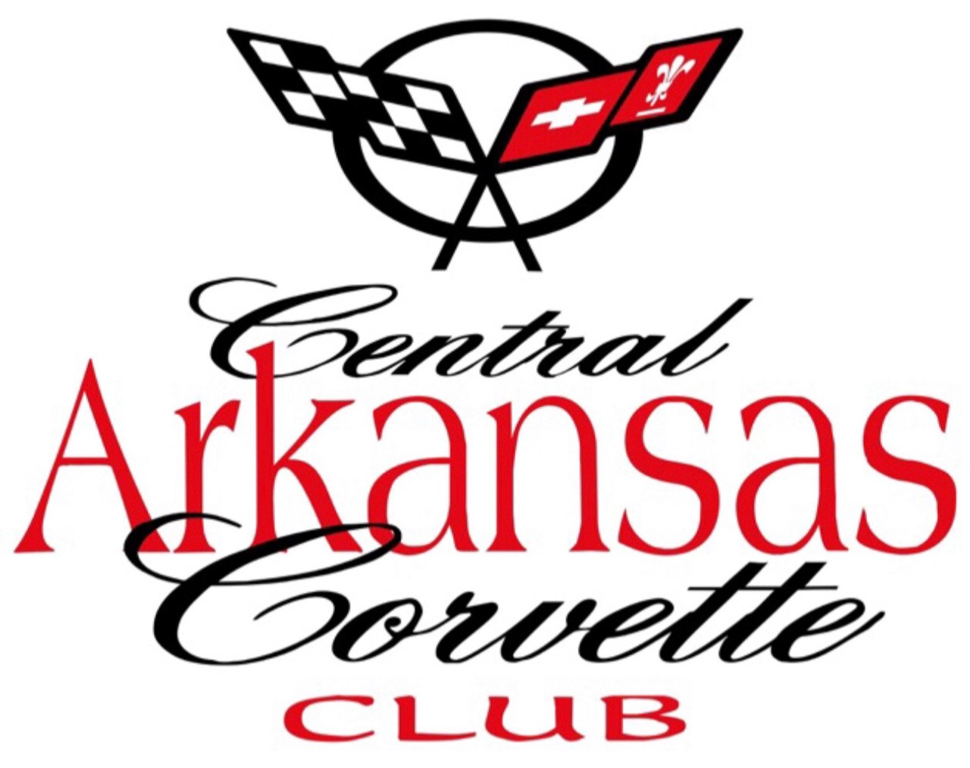
Central Arkansas Corvette Club CONTACT:
P.O. Box 21206 617-308-7354
Little Rock, Arkansas 72221
CentralArkansasCorvetteClub.org
25th Annual Corvette Weekend, Hot Springs, Arkansas
Hot Springs Convention Center
June 11 - 13, 2026
TROPHY SPONSORS

ALL TROPHIES $2500

IF ALL TROPHIES ARE NOT SPONSORED
Best of Show Trophy $500.00
Class Trophies
C1-C5 Class Trophies -$ 400/ea Class
C6-C8 Class Trophies- $600/ea Class

Trophy ___________________________________ Amount ________________

Sponsor Name _____________________________________________________

Sponsor phone and email ____________________________________________
Date __________ Cash__________ Check#_________
Payable to CACC , P.O.Box. 21206, Little Rock, Arkansas 72221
Payment must accompany this order form. ORDER DEADLINE - May 20, 2026
CACC Member coordinating with sponsor _____________________________
Phone and Email___________________________________________________

