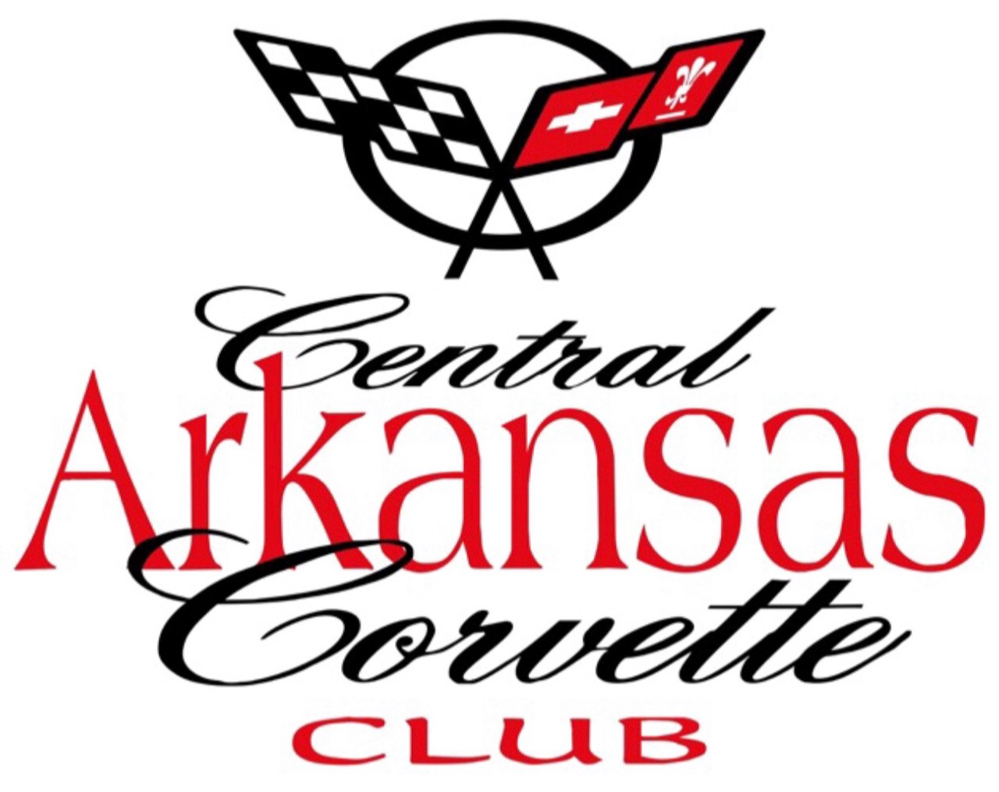
Central Arkansas Corvette Club CONTACT: 617-308-7354
P.O. Box 21206 617-308-7354
Little Rock, Arkansas 72221

CentralArkansasCorve.eClub.org
Sponsor Award - Plaque Request
25th Annual Corvette Weekend, Hot Springs, Arkansas
Hot Springs Convention Center
JUNE 11 - 13, 2026
TO BENEFIT
Multiple Children and Veterans Charities
Name or Business to be Engraved: _______________________________________________
Address: __________________________________________________________________________
Mailing Address City State Zip
Phone #: _________________________ Email _________________________________________
Name of Person Placing Order: _____________________________________________________
Number of Plaques: ___________ X $50.00 = $ _________________
DATE________________ CASH_________________CHECK#________________

Payable to CACC - P.O. Box 21206, Little Rock, Arkansas 72221
Payment must accompany this order form. Order Deadline - MAY 20, 2026
CACC Member Taking Order: _______________________________________________________
Phone and Email____________________________________________________________________

