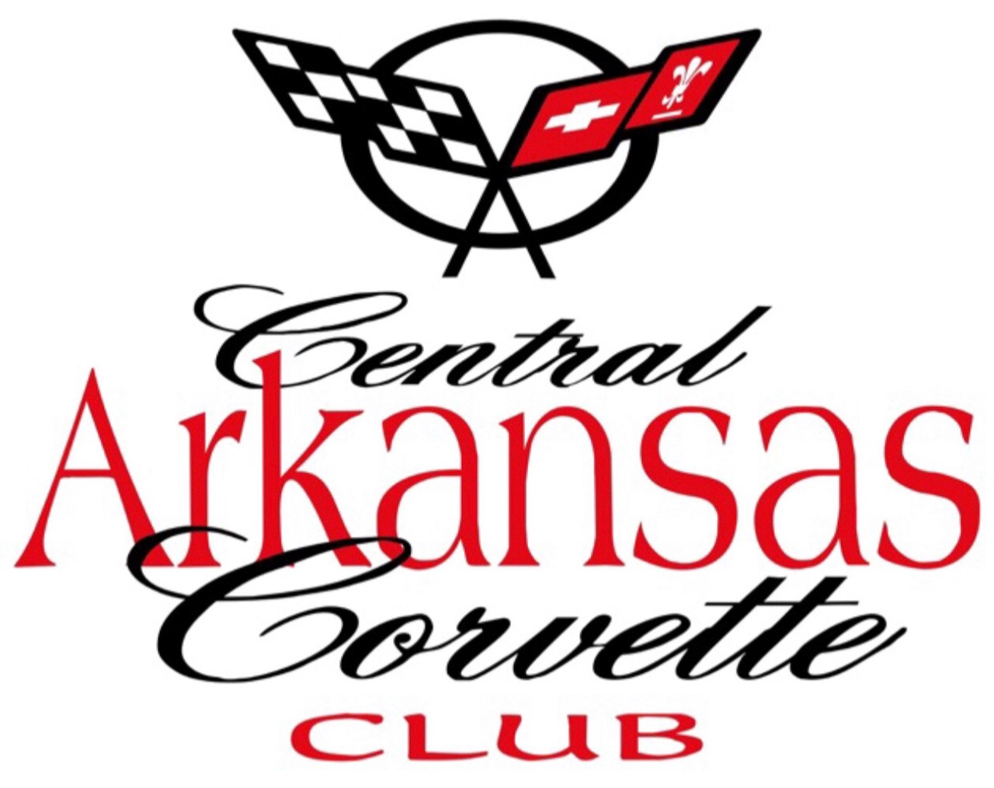
Central Arkansas Corvette Club CONTACT:

P.O. Box 21206 501-940-7448
Little Rock, Arkansas 72221
CentralArkansasCorve.eClub.org
Thank You for Donating a Silent/Live Auction Item

25th Annual Corvette Weekend,
Hot Springs, Arkansas Hot Springs Convention Center
JUNE 11 - 13, 2026
TO BENEFIT
VARIOUS CHILDRENS AND VETERANS’ CHARITIES

Received From: ______________________________________________________________
(Donator)
Address: ____________________________________________________________________________

Mailing Address ________City _________ _____ State ______ Zip __________
Phone and Email ___________________________________________________________________ Date__________________ Value $ _____________________ Description/Instructions: _____________________________________________________
CACC Member: ________________________________________________________________

Coordinating Donation Phone and Email _____________________________________________

