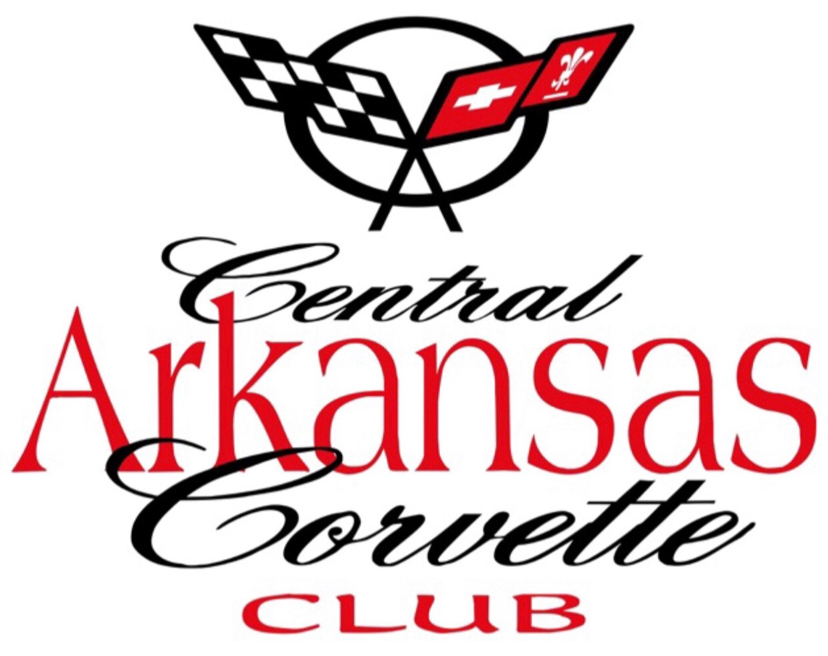
Central Arkansas Corvette Club CONTACT:
P.O. Box 21206 617-308-7354
Little Rock, Arkansas 72221
CentralArkansasCorvetteClub.com
25th Annual Corvette Weekend, Hot Springs, Arkansas
Hot Springs Convention Center
June 11 - 13, 2026

TO BENEFIT Various Children and Veterans Charities 2026 SPONSORSHIP LEVELS
Diamond $5,000.00
Gold $2,500.00
Silver $1,000.00
Diamond Level Benefits- Their Organization will be announced every 15 minutes during the Show. A 3 foot by 12-foot Banner with their Name and Logo will be placed at the Stage. They will receive 4 Show Polo shirts and 6 show “T’ shirts.
Gold Level Benefits-- Their Organization will be announced every 30 minutes during the Show. A 2 foot by 8-foot Banner with their Name and Logo will be placed at the Stage. They will receive 2 Show Polo shirts and 2 Show “T’ shirts.
Silver Level Benefits-- Their Organization will be announced every hour during the Show. A 2 foot by 5-foot Banner with their Name and Logo will be placed at the Stage. They will receive 4 Show “T’ shirts.
All 2026 Corvette Weekend Sponsors will be highlighted on the front page of the Central Arkansas Corvette Club. Sponsors will be highlighted on the CACC Public Facebook page in addition to being listed on the Event Banner during the 3 Days of the Show.
Sponsor Level _____________________ Amount _______________________
Business Name ____________________________________________________
Address__________________________________________________________
Business Contact - Phone and Email___________________________________ Website __________________________________________________________
Date ______________Cash_____________Check#______________
Payable to CACC - P.O. Box. 21206, Little Rock, Arkansas 72221
CACC Member Coordinating __________________________________________________
Phone and Email_____________________________________________________________

